carvings available for immediate sale
- Eagles on my “LineAndBerry” website that are not pictured here can be made to order with a typical lead time of 4 months. See the website for more info on all of my eagles
- I can also work with you to modify or carve any ideas you may have
- Eagles are gilded with 24 karat gold unless otherwise stated
- Price list available on request www.LineAndBerry.com
- Instagram: William Francis Brown (@williamfrancisbrown) • Instagram photos and videos
Wm. Francis Brown Camden, Maine
434-907-5427 dei.gratia123@gmail.com

- 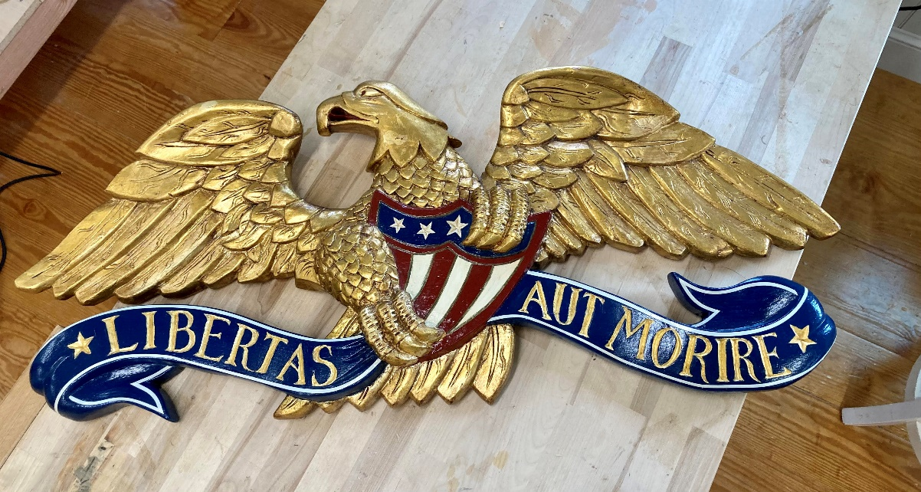
1812 Eagle 35” span x 15” tall x 3” deep Mildly antiqued gold lead
- 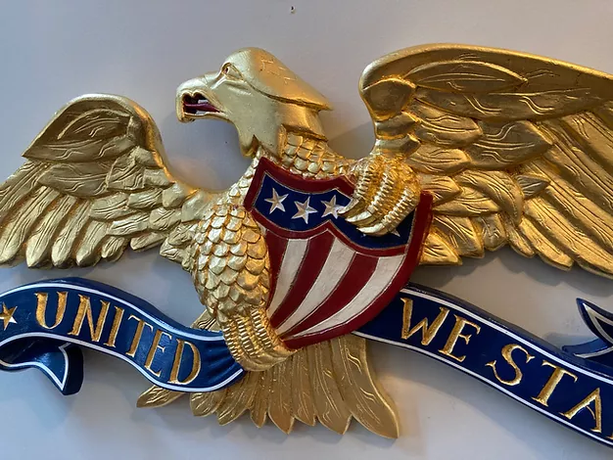
1812 Eagle 35” span x 16 x 3”
- 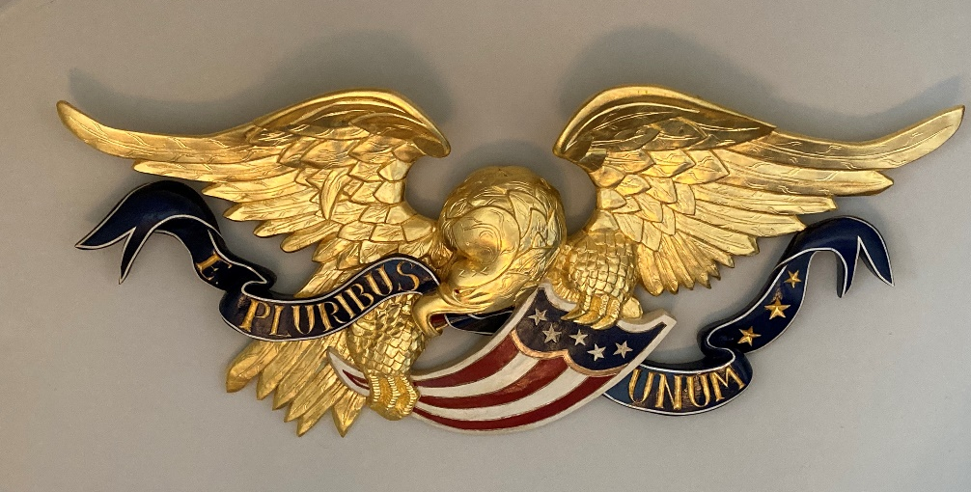
Boston Eagle 47” span x 21” tall x 5 ½” deep

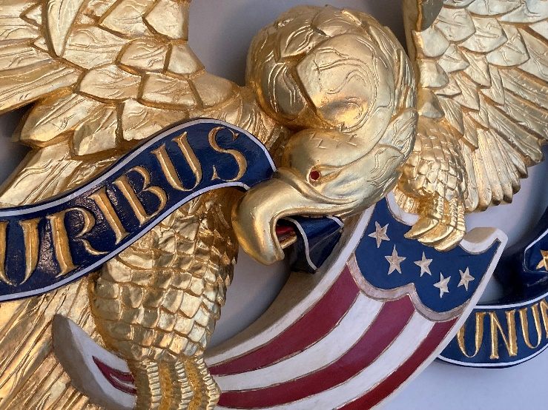

- 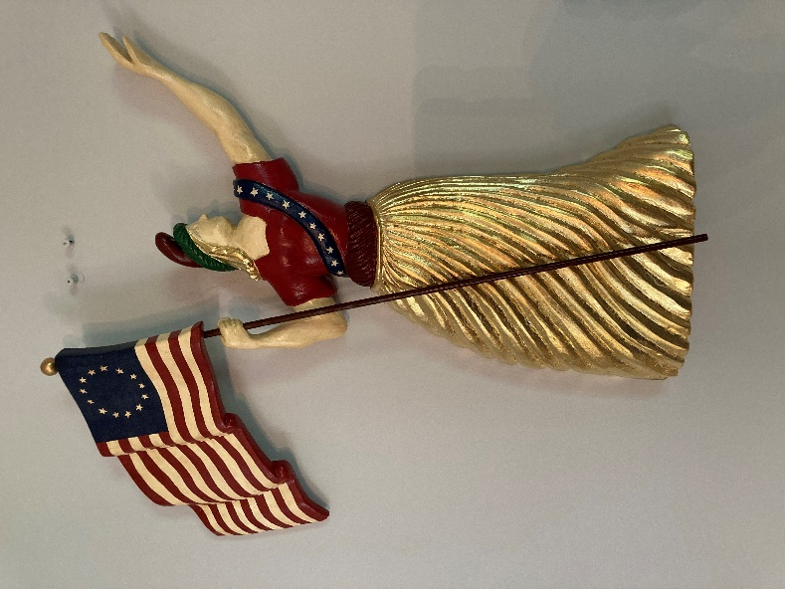
Lady Liberty 18 ½”x 19” x 2 ½”

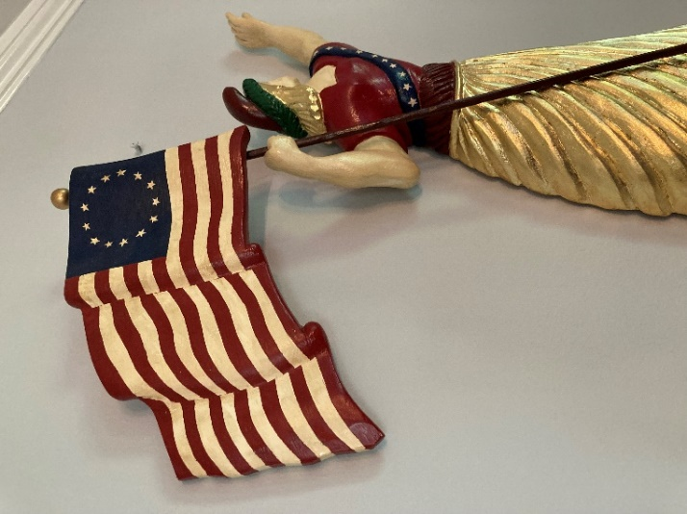

- 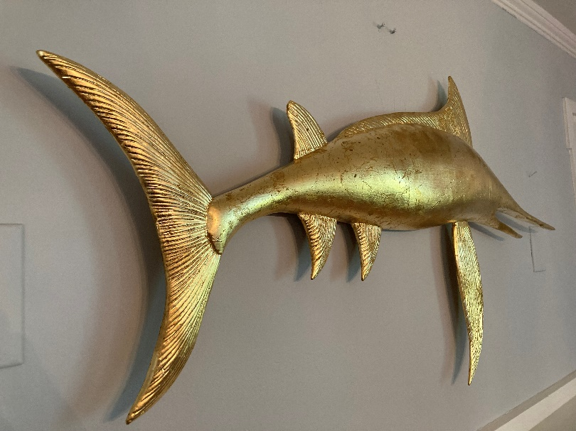

Swordfish 45” wide x 23” tall x 3 “ deep Moderately antiqued & distressed gold leaf

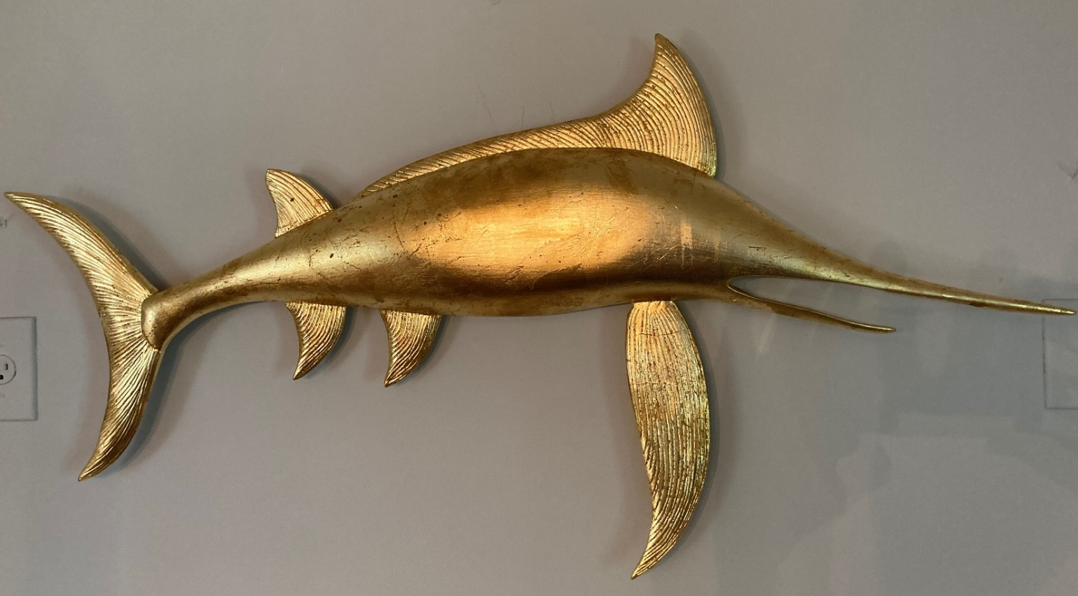

- .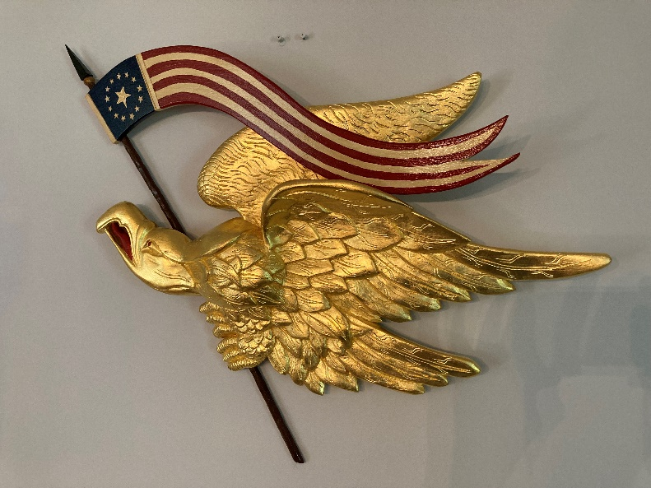
Liberty Eagle 33” wide x 24” tall x 4” deep See more banner options below

- Americana Eagle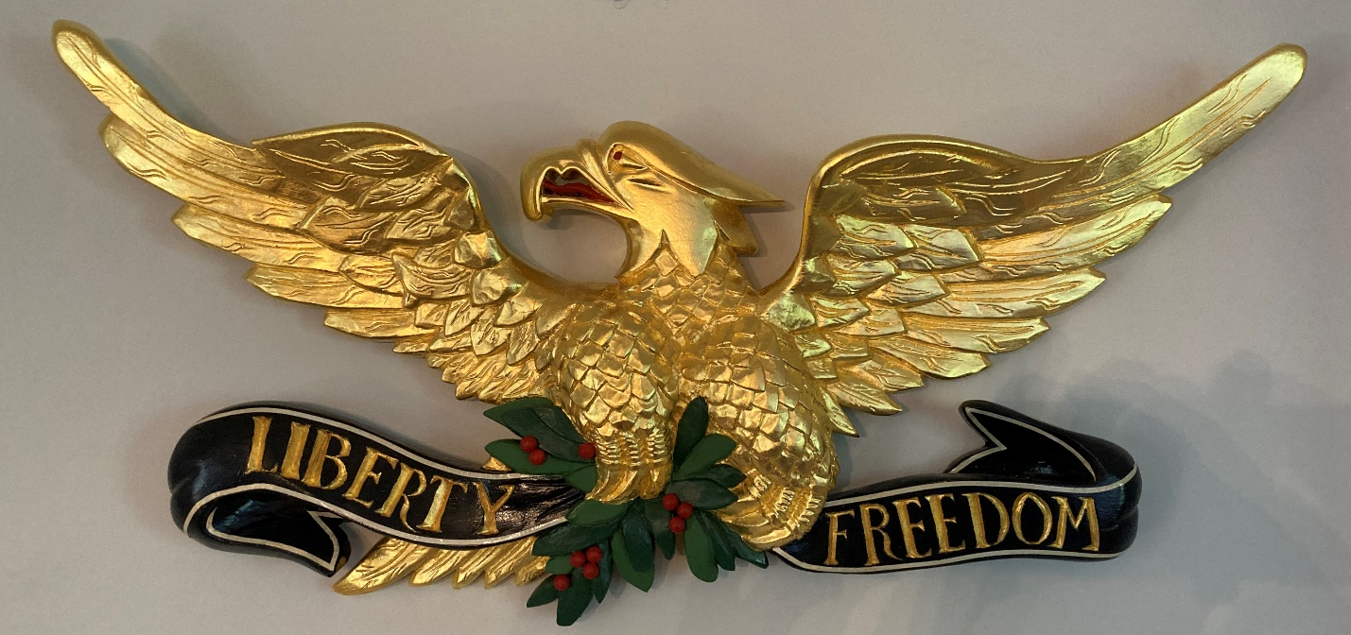
31” span x 16” tall x 3” deep

. 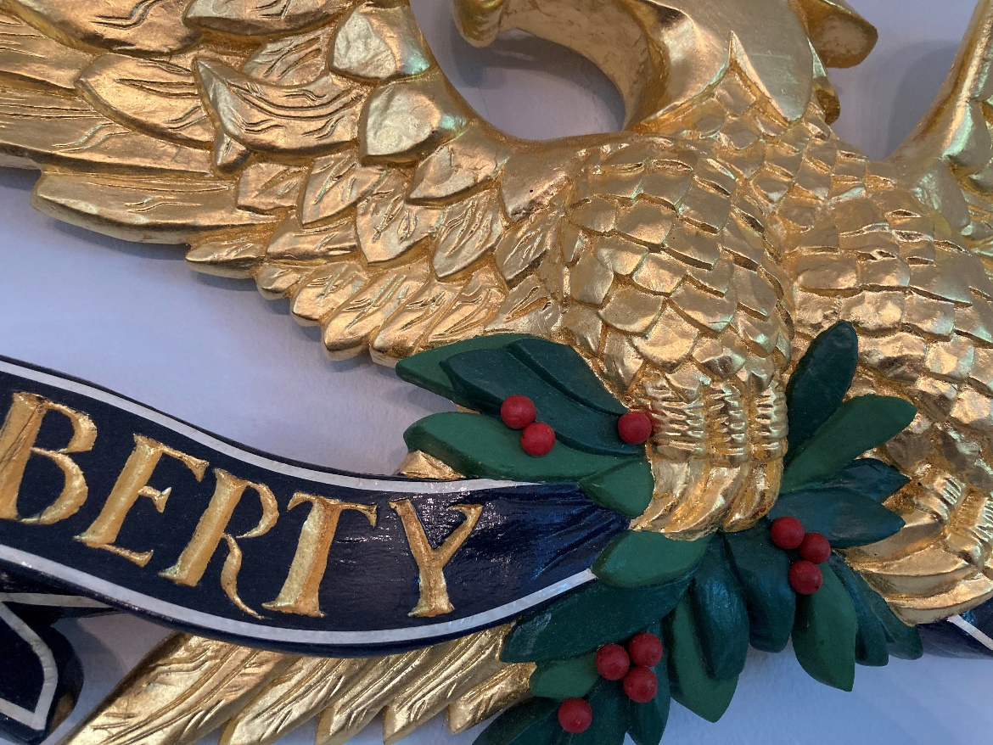

8. Resolute Eagle
8. 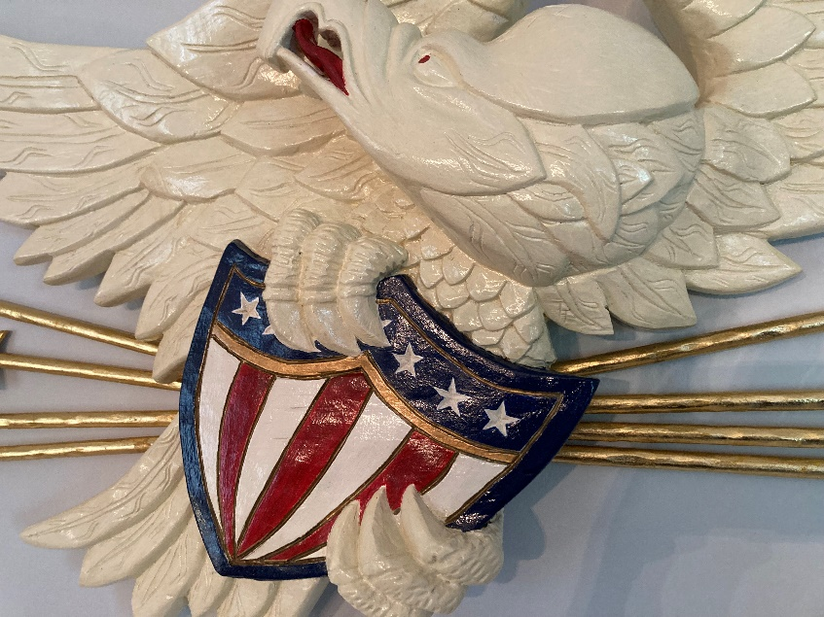 48” wide x 20” tall x 5” deep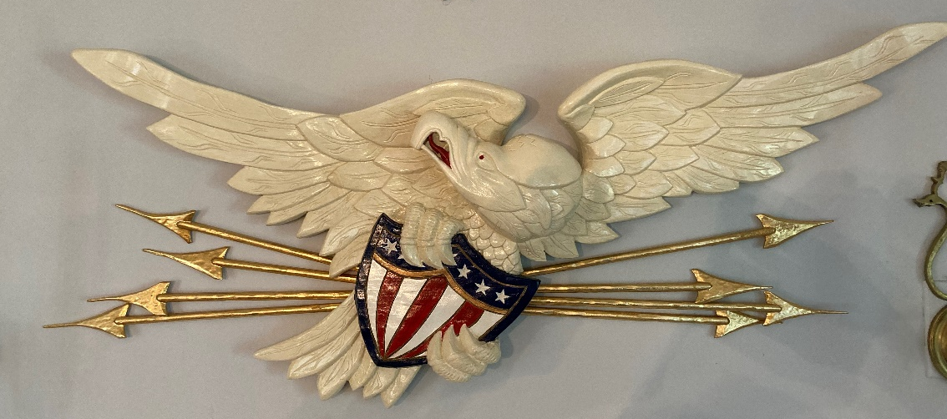
8. 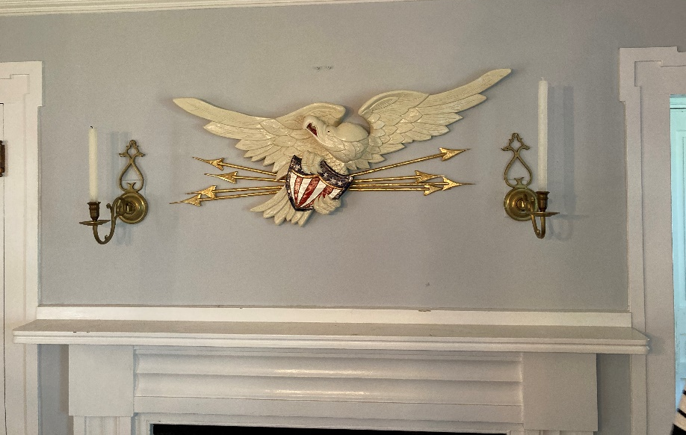

9. 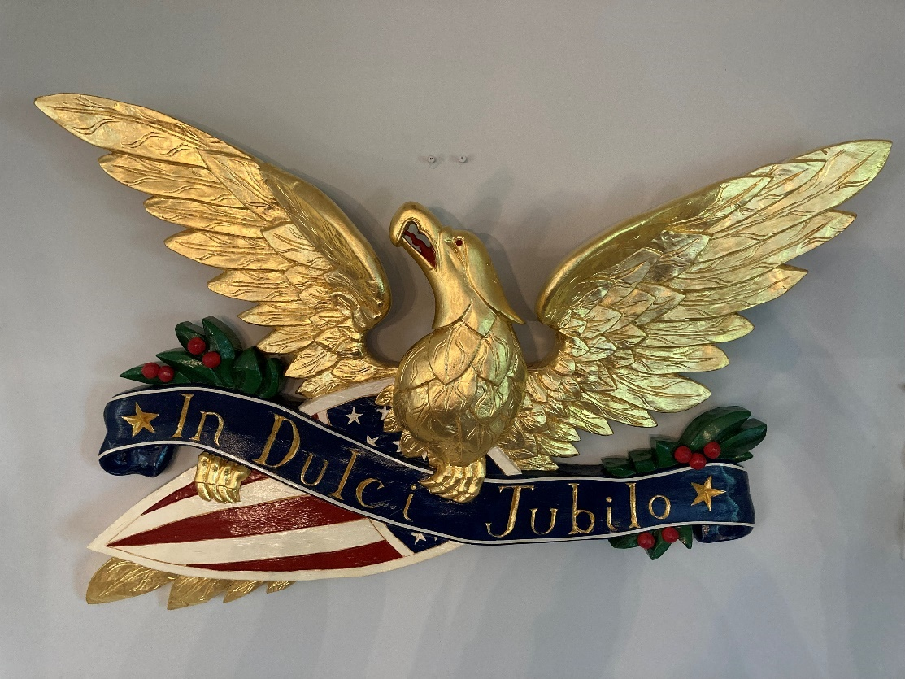

“In Dulci Jubilo” (With Sweet Rejoicing) 38” span x 23” tall x 4” deep

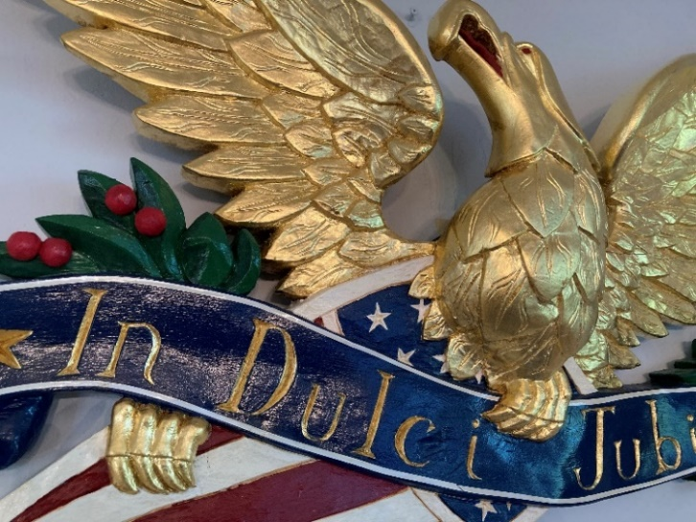

10. 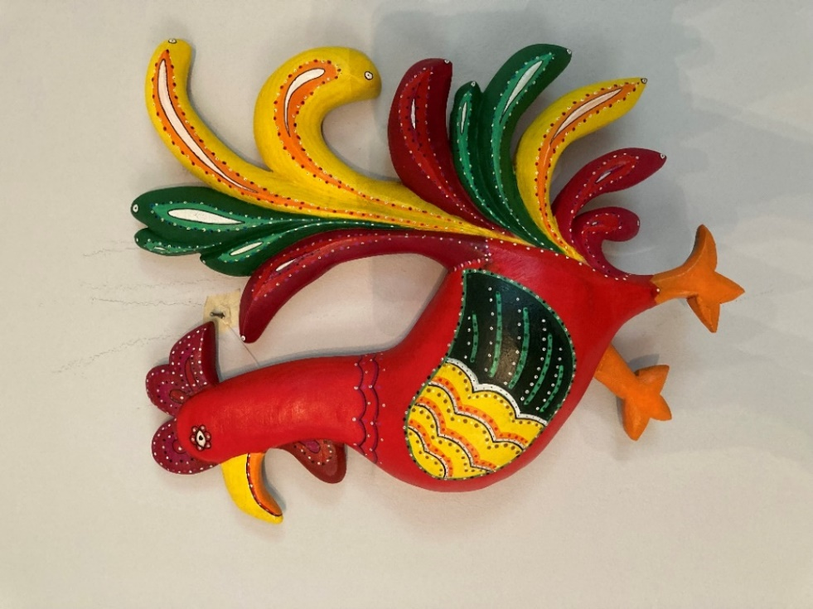
Fancy Rooster I 16” tall x 12” wide x 2 ½” deep

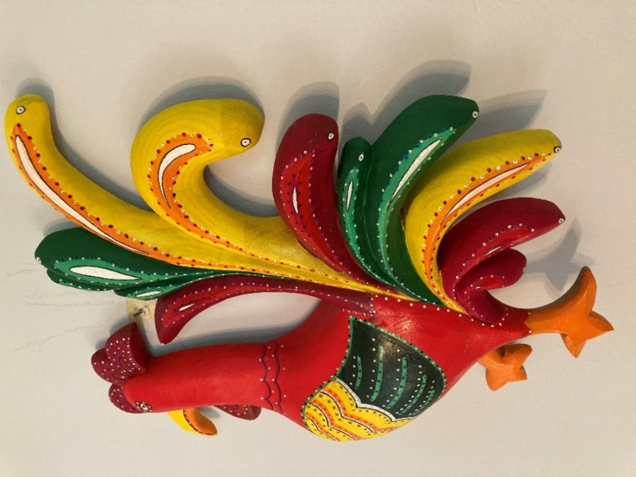
11. 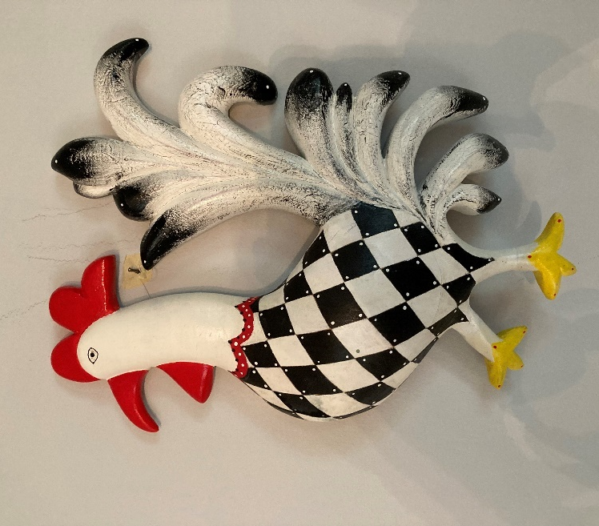 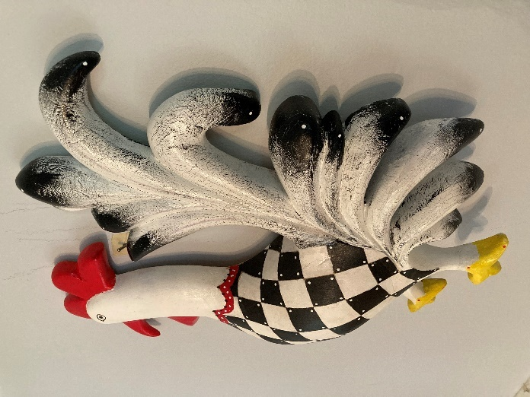
Fancy Rooster II 16” tall x 12” wide x 2 ½ ” deep
________________________________________________________________________________________

12. Reverse Wing Bellamy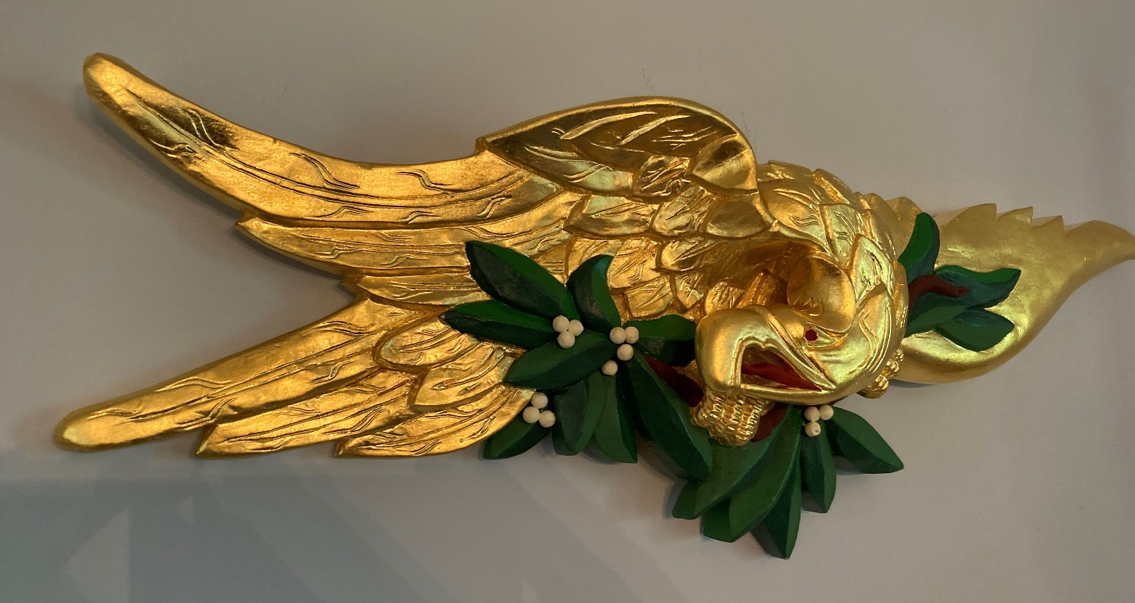
Reverse Wing Bellamy 33” span x 11” tall x 4” deep
12. 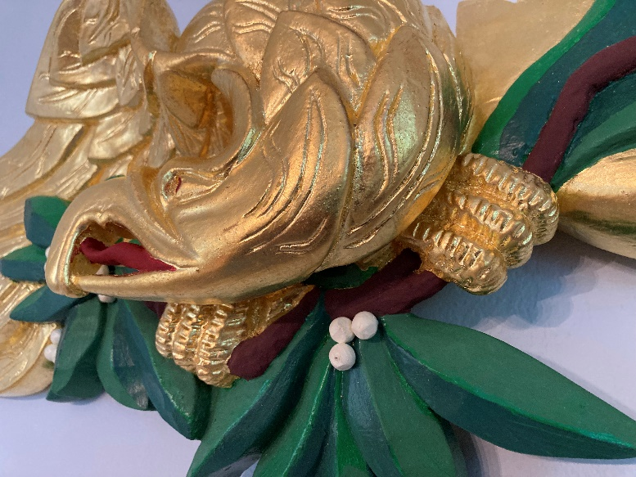

___________________________________________________________________________________

13. 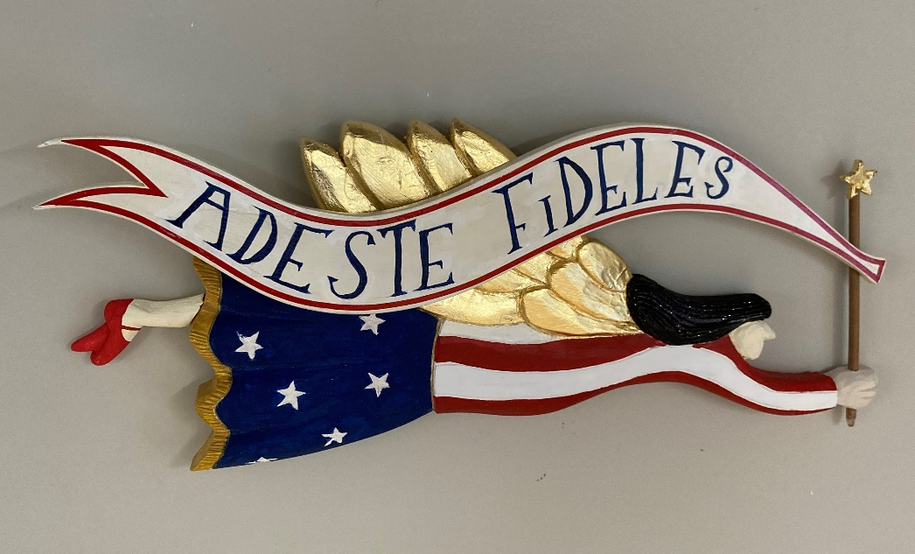
Folk Angel

14. 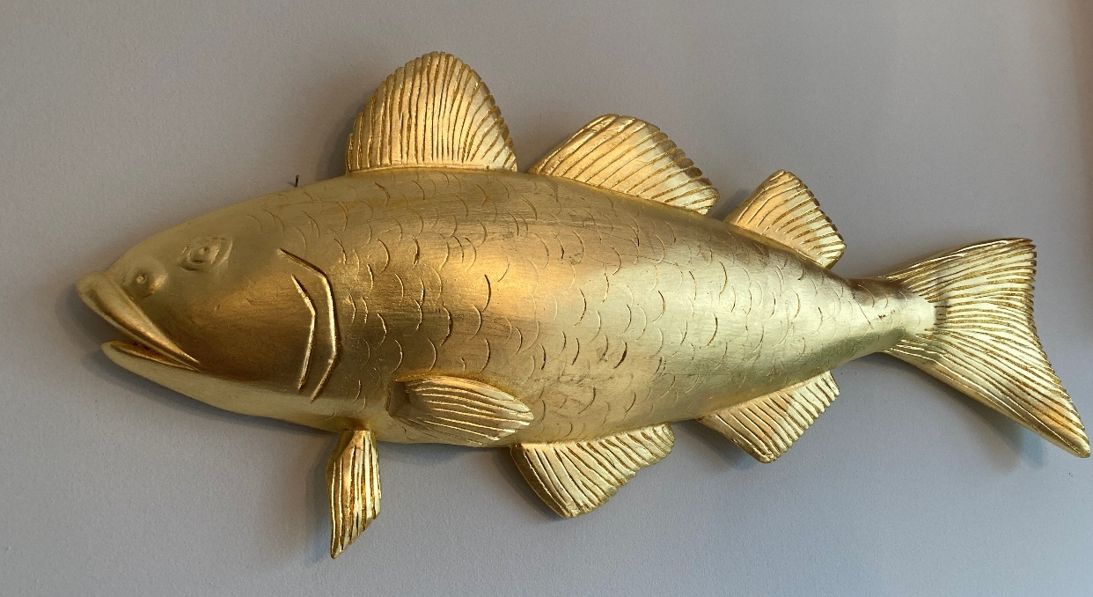
Codfish 2 available for immediate shipment: 26” and 18 ½” long
15. Pineapple 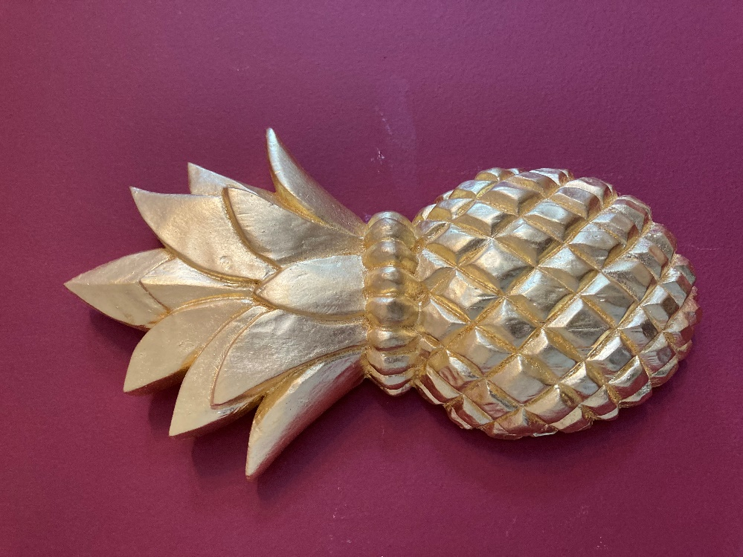
12” tall
__________________________________________________________________________

16. 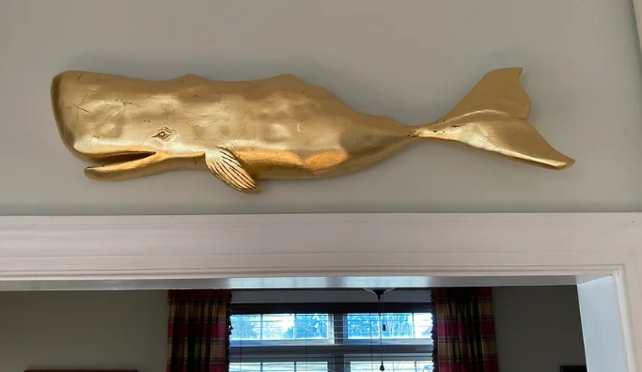
Whale 29 Inches
17. 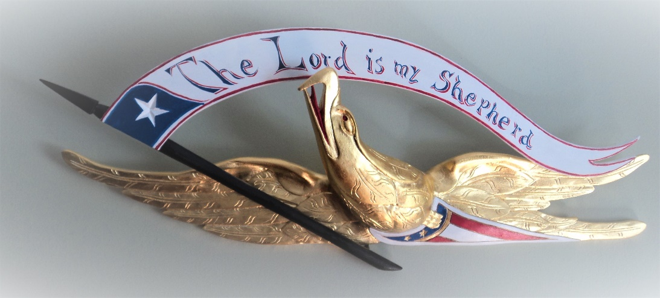 24” span x 9 ½ x 3”
‘The Lord is My Shepherd’ Bellamy

18. 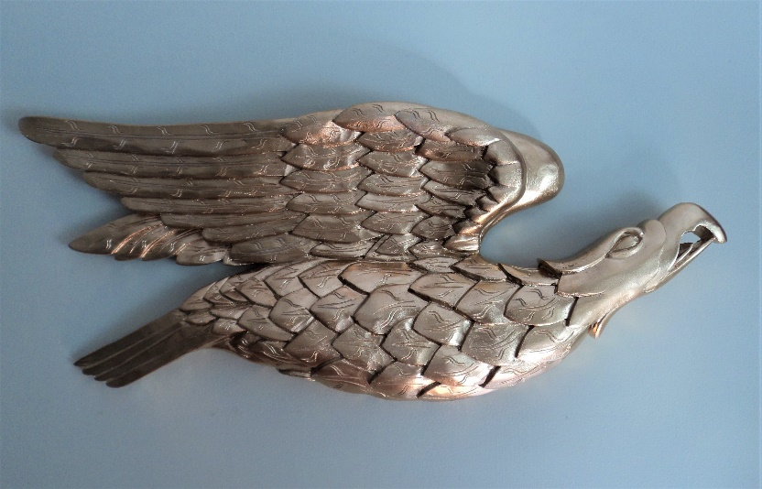 25” span x 11” tall x 2 “ deep
‘Soaring’ Bellamy Eagle Burnished, antiqued gold leaf

___________________________________________________________________________________________

19. Classic Bellamy Eagle
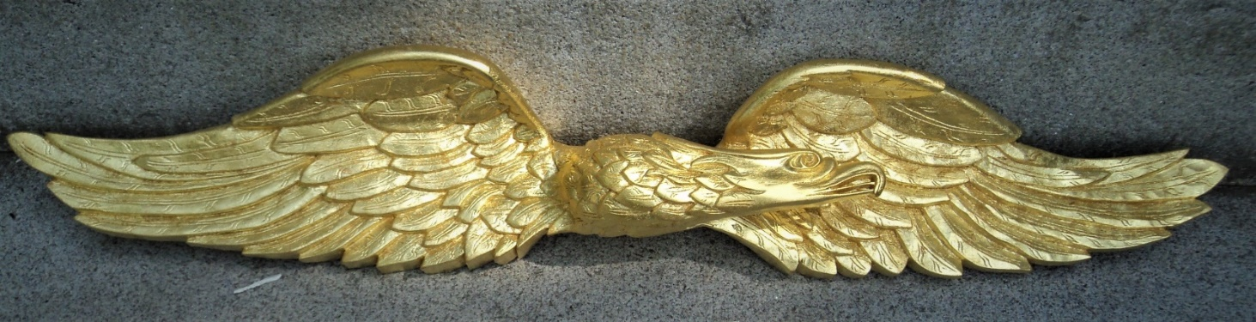
Available for immediate shipment in 50” and 34” sizes
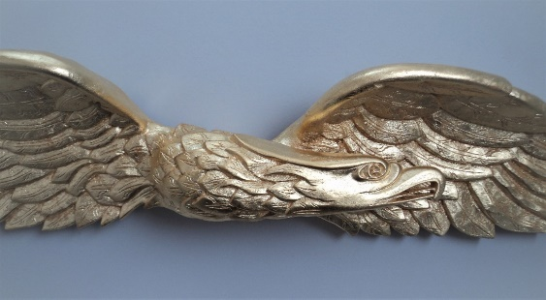
20. 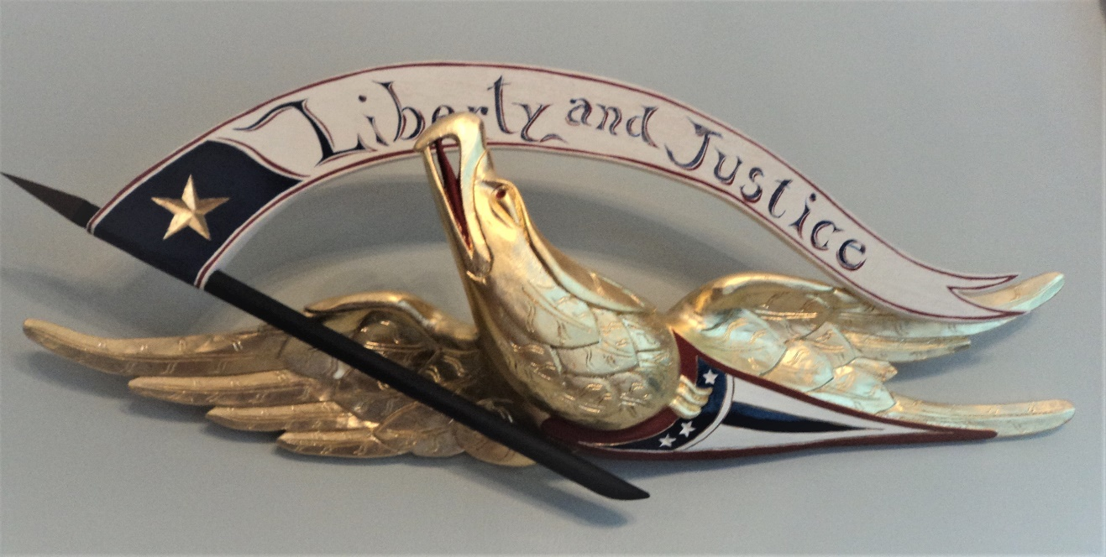
‘Liberty & Justice’ Bellamy Eagle 29” span x 15 x 4”

21. 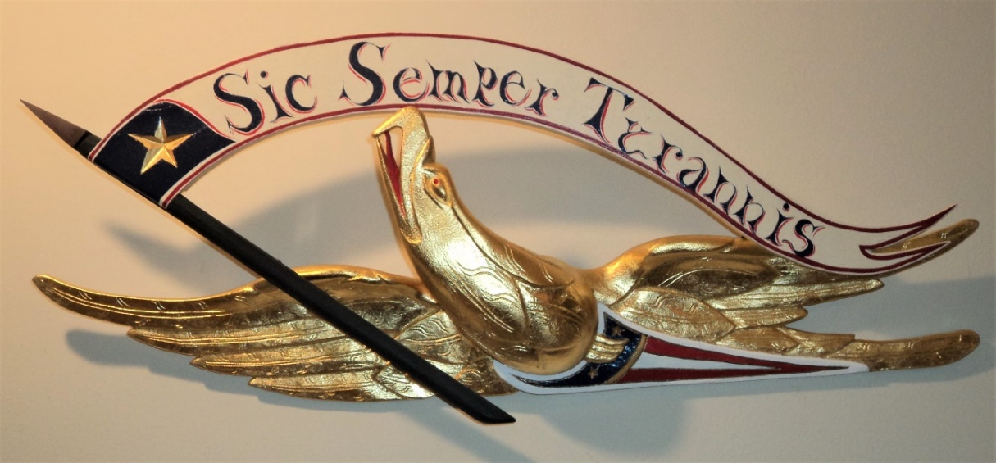
Sic Semper Tyrannis’ (Thus always to Tyrants) Bellamy 24½” span x 9½ x 3½ “

22. 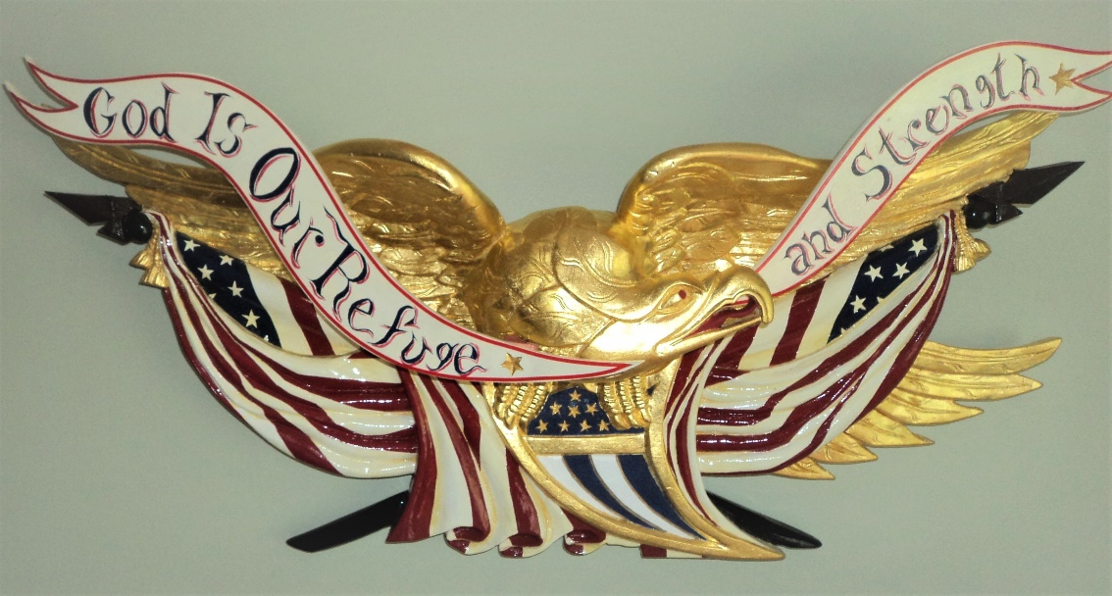
‘God is Our Refuge and Strength’ Bellamy Eagle
35 ½” span x 14” tall x 5” deep

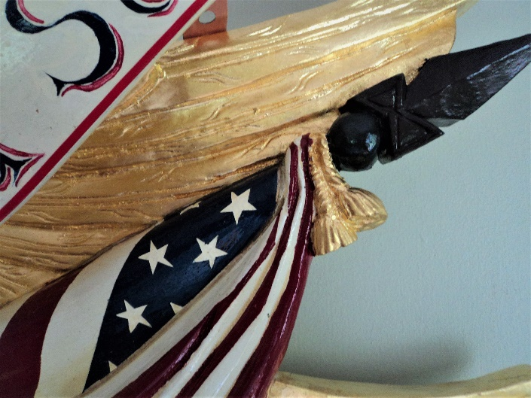 Detail of #22
__________________________________________________________________________________________

23. ‘Faith, Hope, & Charity’ Bellamy Eagle 30 inch x 8 x 4 1/2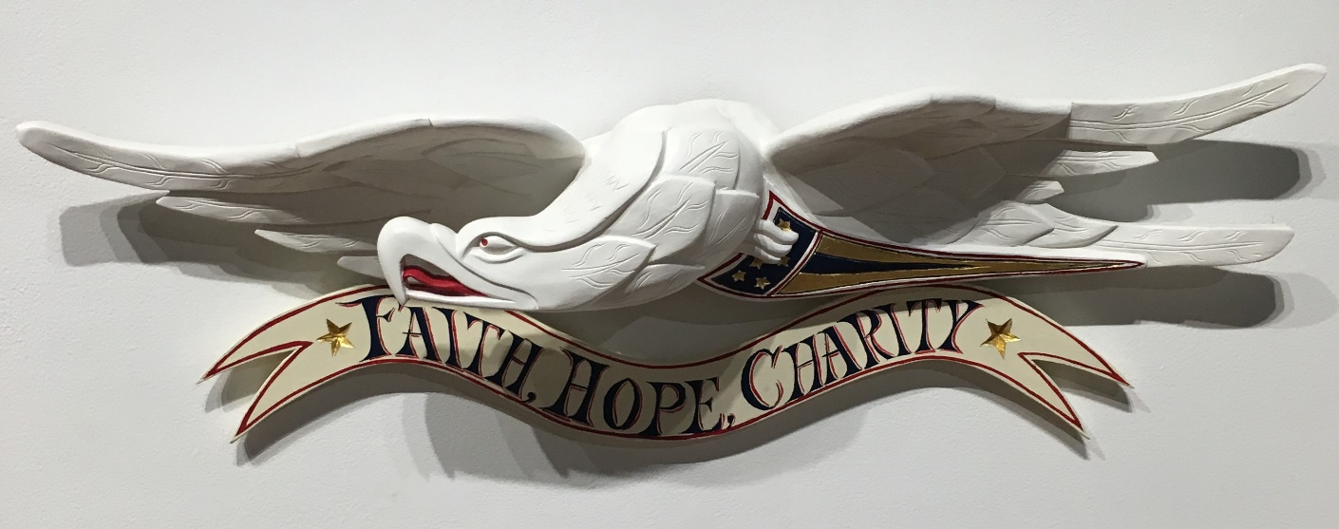

24. 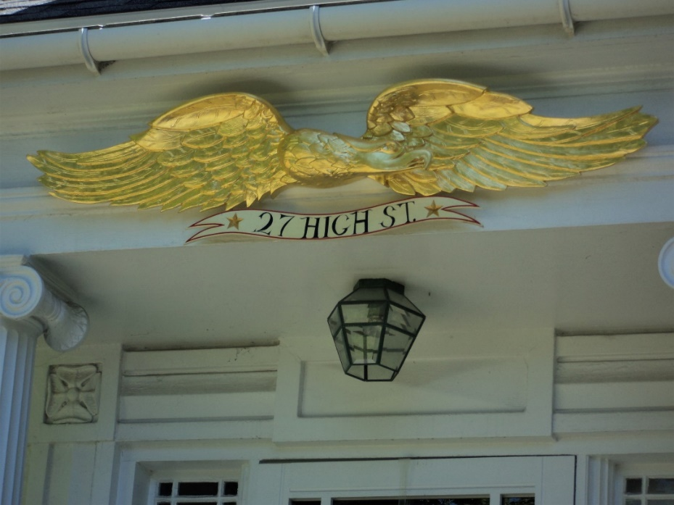
Classic Bellamy Eagle 5 feet. Can add sign of your choice or go without

25. 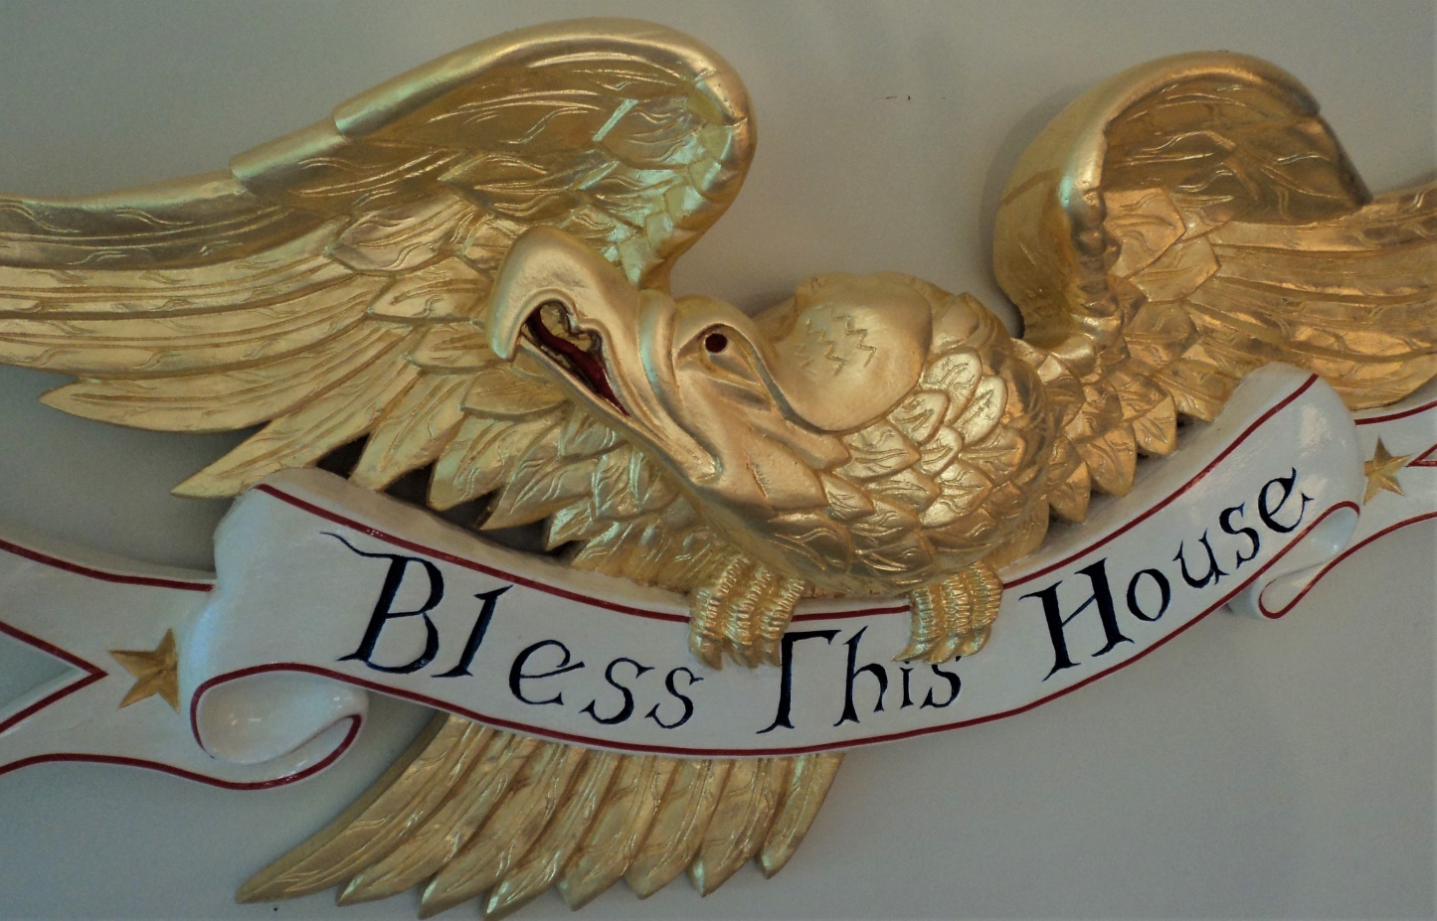
‘Bless This House’ Bellamy 36” span x 16” tall x 4” deep

26. ‘Freedom’ Bellamy Eagle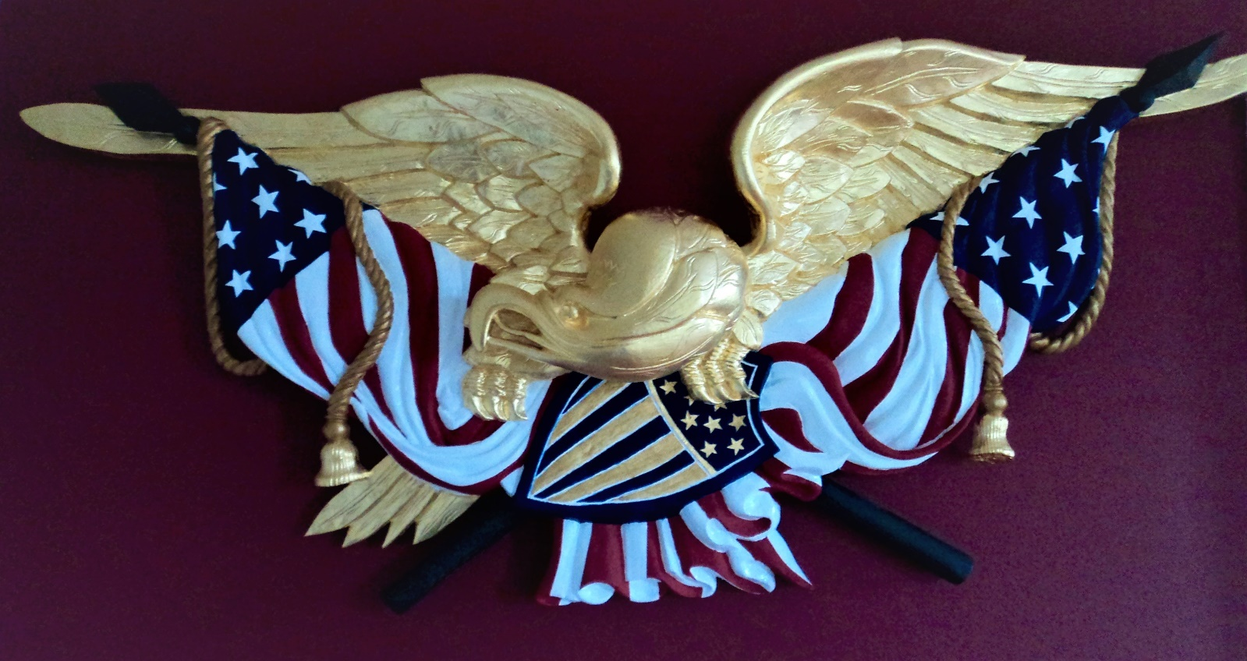
43” wingspan
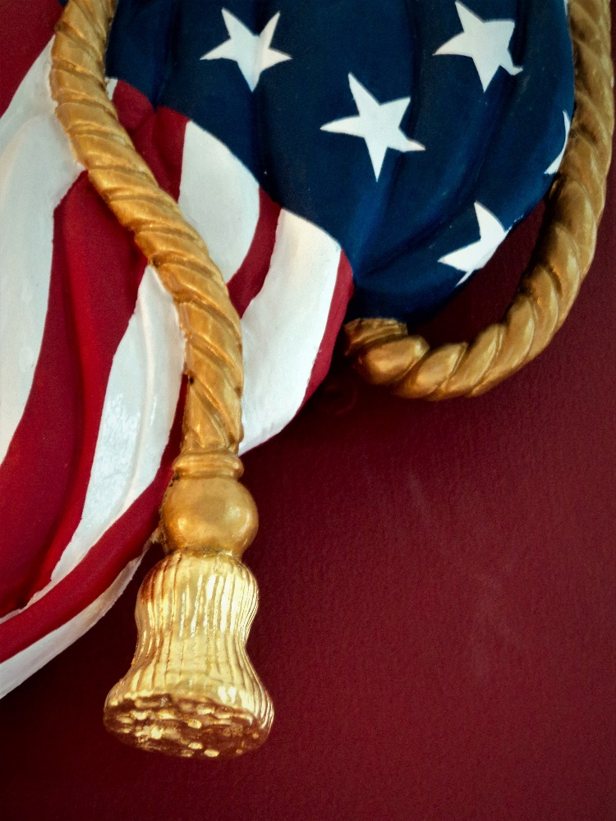 Detail of #26

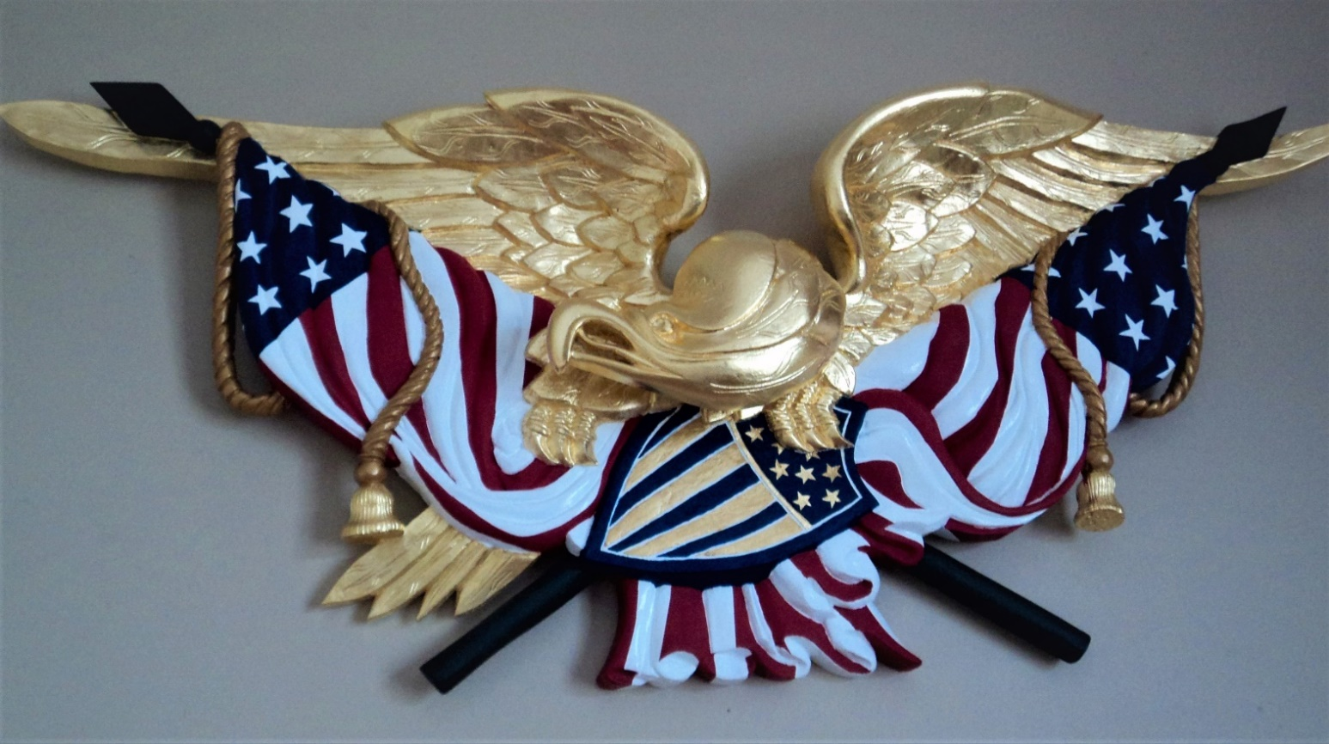

27. 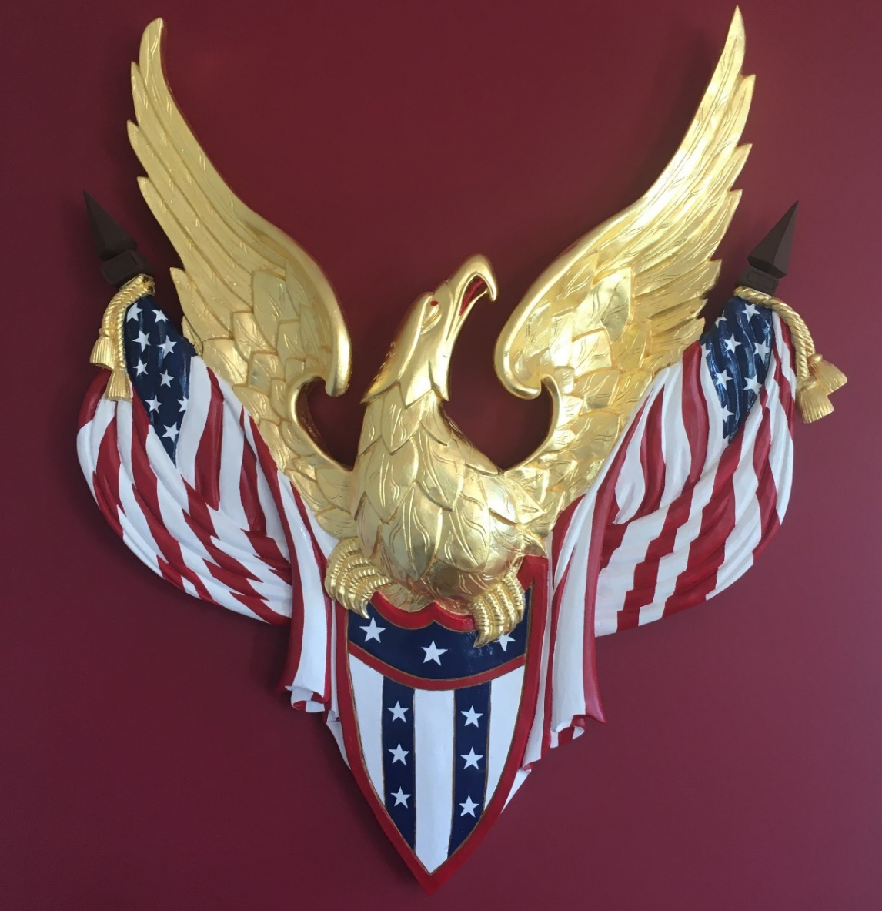
Vertical Bellamy 4 feet x 4 feet x 4” deep

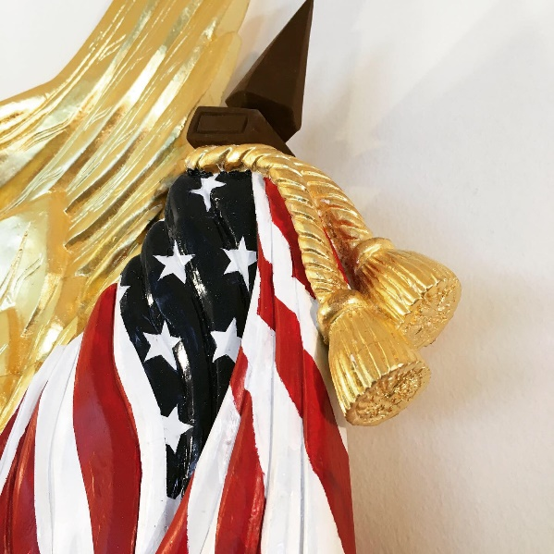 Detail of #27

28. 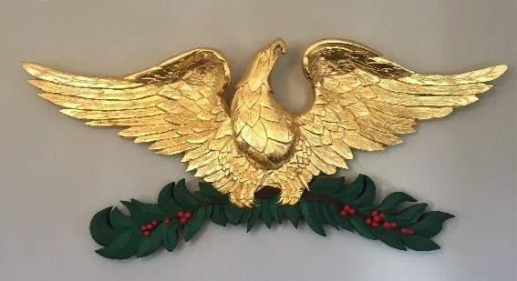
Yuletide Bellamy 50” span x 23” tall x 4” deep

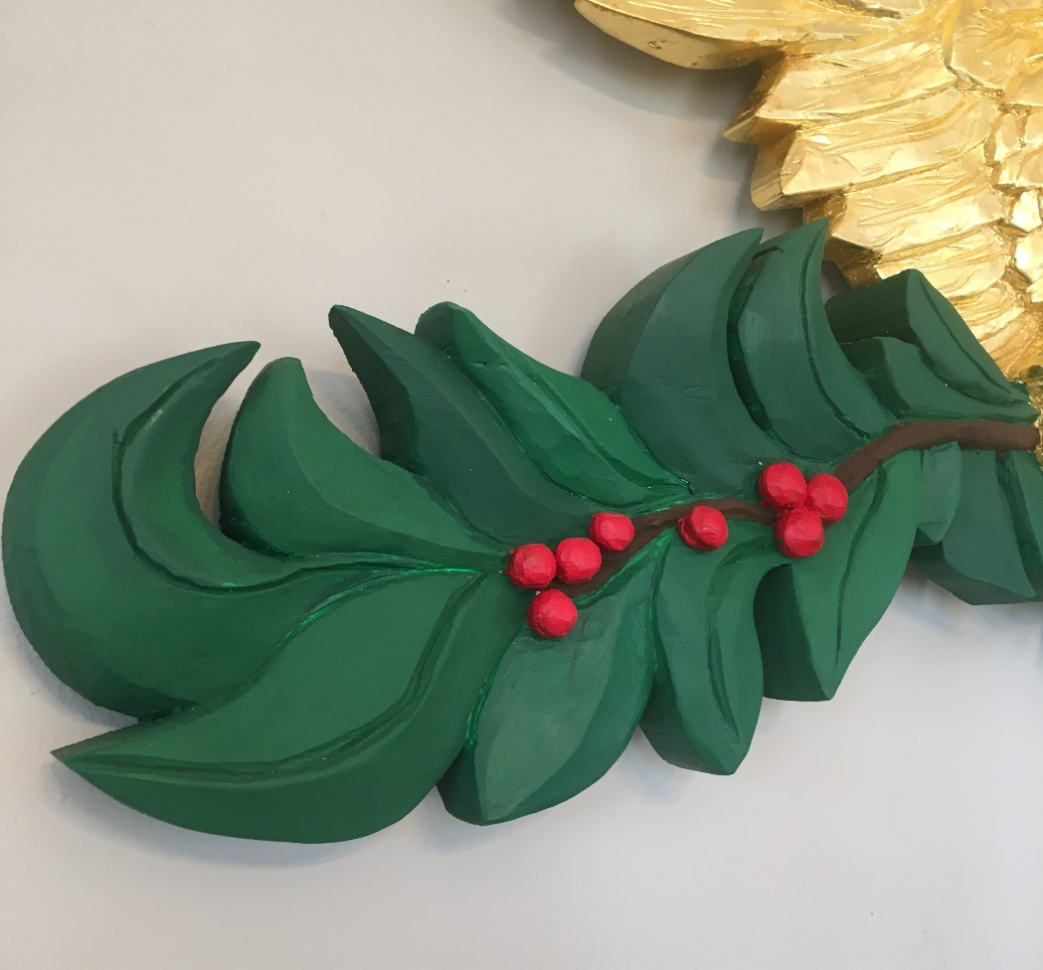

29. Spread Wing Bellamy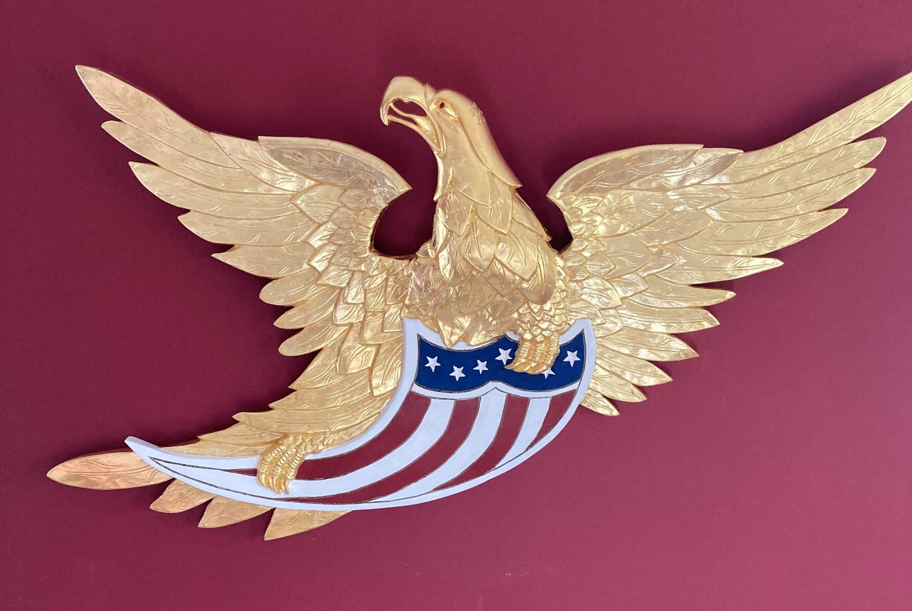
4 feet x 4 feet

30. 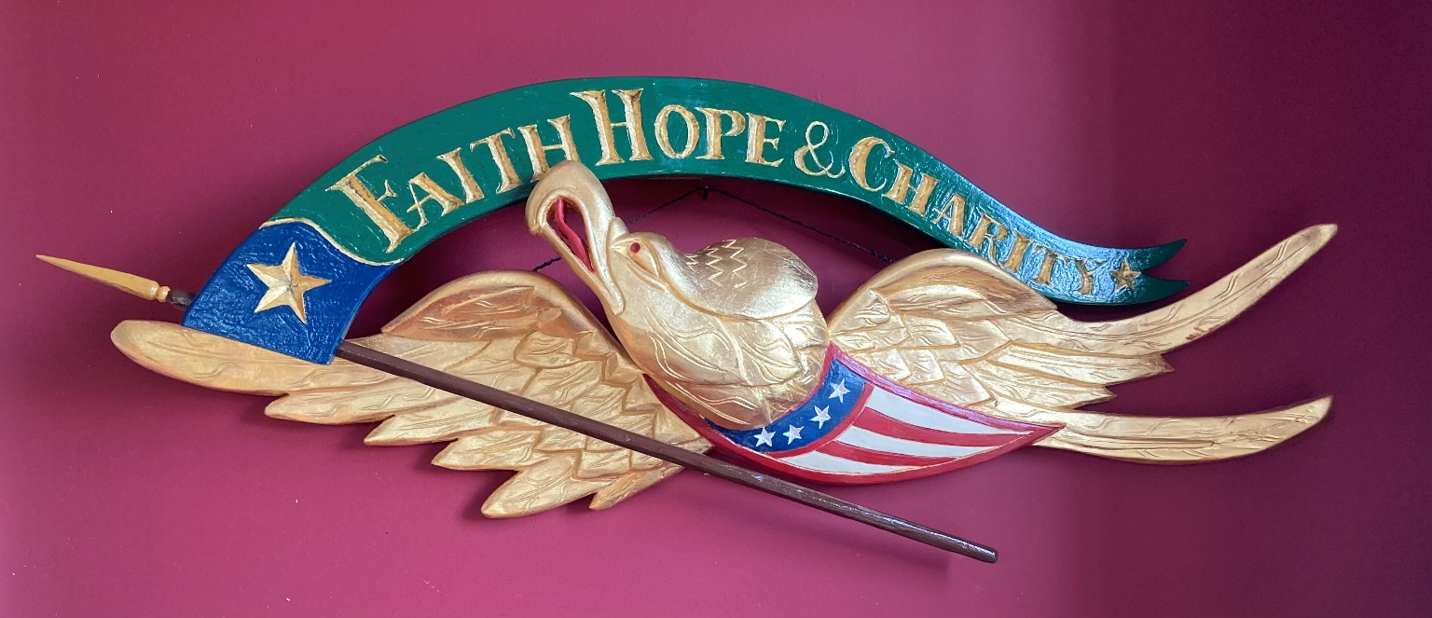

“Faith, Hope, Charity” Bellamy 32” wingspan

31. 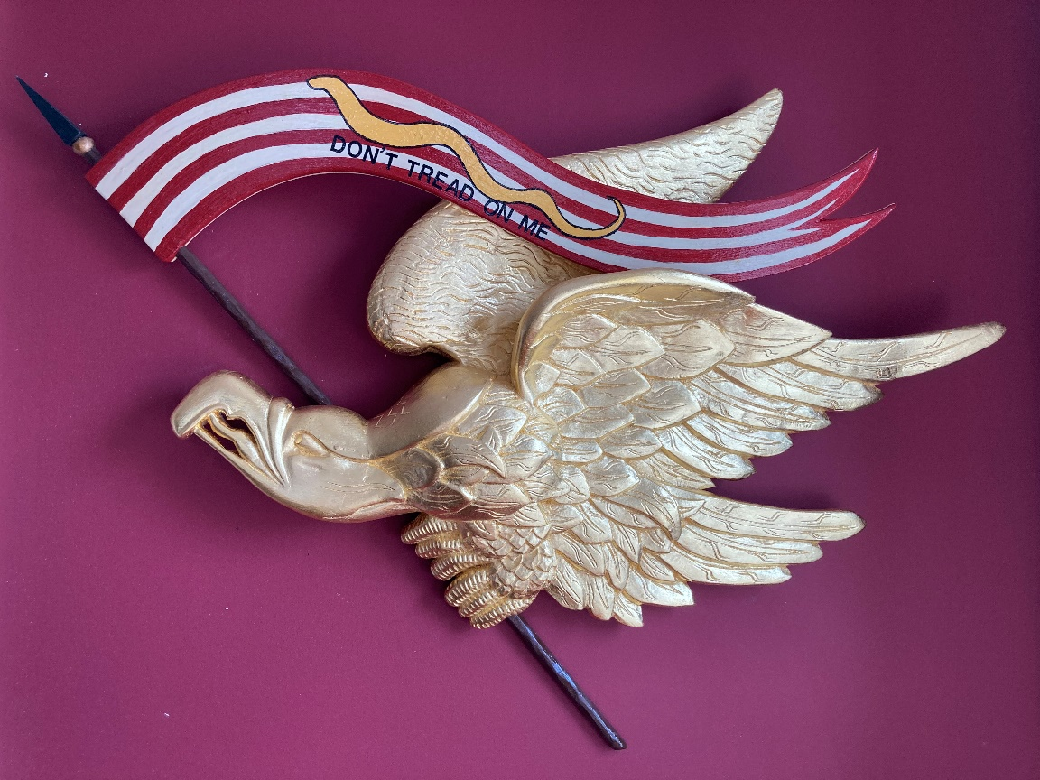
Liberty eagle 33” wide x 23” tall x 4” deep. More Banner styles available or customize

32. 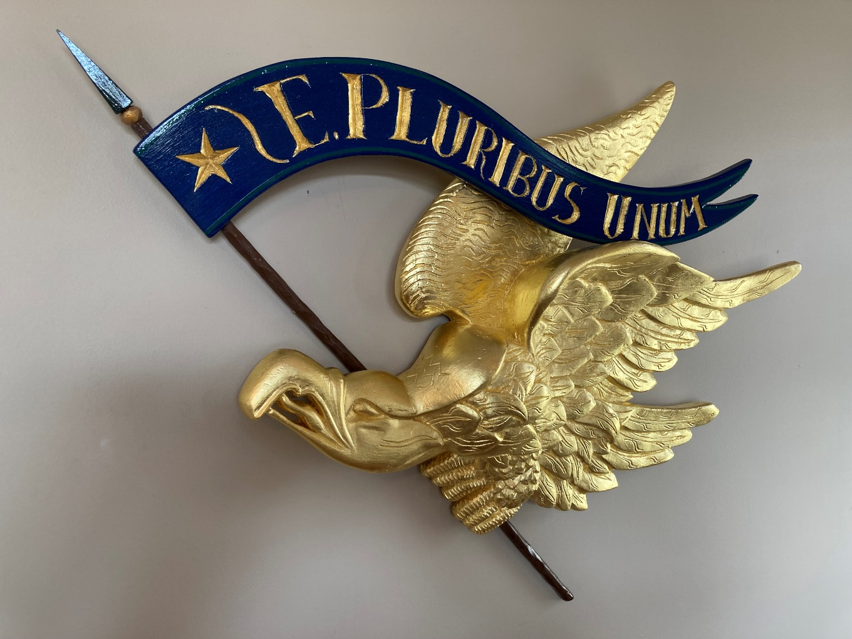
“E. Pluribus Unum” Liberty Eagle

